Project documentation

**Title - Nutrition, Physical Activity and Obesity Behavioral Risk Factor**

**Surveillance System**

**1.Overview:**

This Power BI project explores and visualizes public health data related to Nutrition, Physical Activity, and Obesity across U.S. states and territories. The data is sourced from the Canters for Disease Control and Prevention (CDC) and aims to support data-driven decisions for improving public health awareness and intervention strategies.

**1.Tools used:**

* Microsoft Excel
* Microsoft Power BI

**2.Dataset**

* Dataset [https://docs.google.com/spreadsheets/d/1DdWByDRFz1mPKaagxBtjpFbK5vlIke97/edit?usp=sharing&ouid=115231710339641600291&rtpof=true&sd=true](https://docs.google.com/spreadsheets/d/1DdWByDRFz1mPKaagxBtjpFbK5vlIke97/edit?usp=sharing&ouid=115231710339641600291&rtpof=true&sd=true%20%20%20)
* Data contains: Nutrition, Physical Activity, Obesity data by U.S. state
* Fields: State, Year, Category, Class, Gender, Value, Confidence Interval etc.

**3.Steps Followed:**

* Cleaned data in Excel using Power Query (removed special characters, unwanted & blank columns, formatted rows)
* Applied Excel formulas for data preprocessing
* Imported cleaned data into Power BI
* Created measures and calculated columns using DAX
* Built an interactive report with charts, graphs, and KPIs

**4.Key insights:**

* + 🔢 Total Sample Size:
* Over 271 million responses were analysed from behavioural surveillance data related to nutrition, physical activity, and obesity.
  + 📈 Regional Trends:
  + Southern states show the highest data values across all health classes, especially for obesity-related metrics.
  + West and Midwest regions demonstrate better performance in physical activity levels with lower average error margins.
  + 💬 Confidence Intervals & Data Reliability:
* The confidence interval width is highest in obesity data, showing greater variability and uncertainty compared to other classes.
* Physical activity class has the tightest confidence range, reflecting more consistent data.
  + 💸 Income vs Obesity:
  + A clear inverse relationship exists — lower income levels correlate with higher obesity values.
  + The highest obesity values are reported from those earning less than $15,000/year.

**5.Files Included:**

Cleaned data file - [https://docs.google.com/spreadsheets/d/1NYjI137xJGgZWdEDtG00EE9gGMJ-LxQS/edit?usp=sharing&ouid=115231710339641600291&rtpof=true&sd=true](https://docs.google.com/spreadsheets/d/1NYjI137xJGgZWdEDtG00EE9gGMJ-LxQS/edit?usp=sharing&ouid=115231710339641600291&rtpof=true&sd=true%20%20)

Mini Project Report File - [https://drive.google.com/file/d/16v44O3YR3wl0Bc6hJYCe8OXaZCxPKUZN/view?usp=sharing](https://drive.google.com/file/d/16v44O3YR3wl0Bc6hJYCe8OXaZCxPKUZN/view?usp=sharing%20)

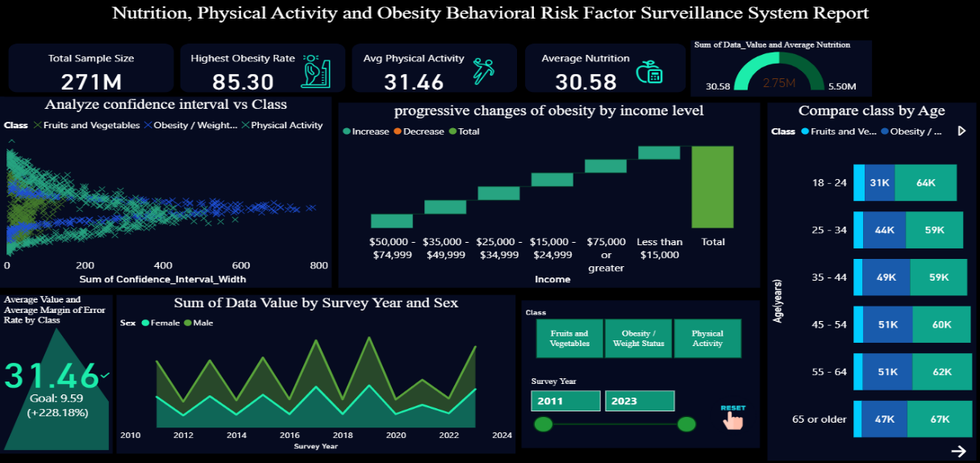**6.Screenshots:**

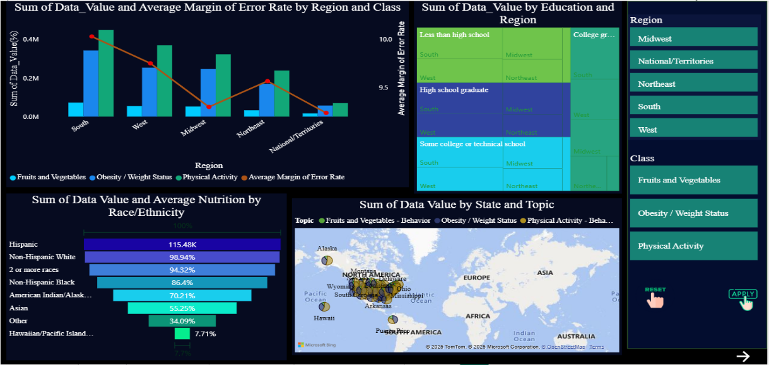

**8. How to use:**

* Open [https://docs.google.com/spreadsheets/d/1NYjI137xJGgZWdEDtG00EE9gGMJ-LxQS/edit?usp=sharing&ouid=115231710339641600291&rtpof=true&sd=true](https://docs.google.com/spreadsheets/d/1NYjI137xJGgZWdEDtG00EE9gGMJ-LxQS/edit?usp=sharing&ouid=115231710339641600291&rtpof=true&sd=true%20%20)  to view the cleaned data.
  + Open [https://drive.google.com/file/d/16v44O3YR3wl0Bc6hJYCe8OXaZCxPKUZN/view?usp=sharing](https://drive.google.com/file/d/16v44O3YR3wl0Bc6hJYCe8OXaZCxPKUZN/view?usp=sharing%20) in Power BI Desktop to explore the visuals.